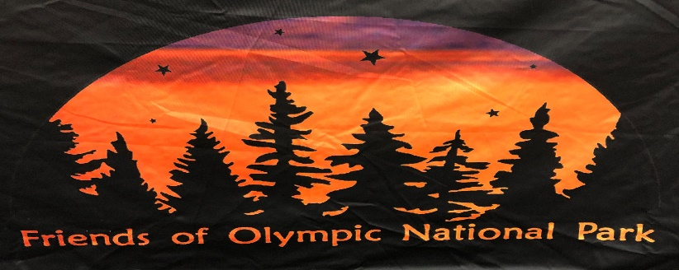

Membership Application/Renewal 2024

Included in Membership is an FONP car decal and inclusion on our membership email list to receive newsletters and updates on volunteer activities. Choose one:
Individual $25.00 annually
Family $30.00 annually
Student $15.00 annually
Current Armed Services $15.00 annually
New Members: ONP Volunteers and ONP Season Pass Holder – First Year Free!
I am paying this amount today $____ for an annual FONP membership.
I would like to pay this amount today $____ for a membership, plus am including $______ for a donation.
I am not interested in becoming a member, but would like to donate this amount $______

Name: ___________________________________________________________________
Mailing Address: ___________________________________________________________
City: _______________ State: ___________________ Zip: _________________
Telephone: _______________________________________________________________
Email: ___________________________________________________________________

I am interested in volunteering at FONP-sponsored activities: Yes No

